Rolling correlation: GBPUSD and NZDUSD
Method 05 / daily log returns / windows 20, 60, 100 / Secondary tier

Study setup
Logical pair: GBPUSD , NZDUSD
Broker symbols: GBPUSD_i , NZDUSD_i
Tier: Secondary tier (secondary)
Snapshot: 2026-11-03_majors_alpari_D1
Timeframe: D1
Matched return window: 1999-01-05 to 2026-11-02 (UTC bar dates)
Matched return count (rows before rolling): 7203
Dropped unfinished last bar dated 2026-11-03 UTC after a tick-volume check against the prior complete day.
Rolling windows W: 20, 60, 100 trading days
Live-shaped n for each score: n = W (not the full history length)
Complete matched rows (CSV): GBPUSD-NZDUSD_Rolling_D1.csv
Complete matched rows (HTML): GBPUSD-NZDUSD_Rolling_D1_data.html

Method carried forward
Rolling Pearson r is computed on matched daily log returns of close, ln(close_t / close_t-1), in the broker quote direction. Quotes are not inverted. For each day t with a full window, r_W uses the last W matched return pairs ending at t. That live-shaped sample size is W (20, 60, or 100), not the full multi-year history. The first W-1 days have no score. r is symmetric under swap of the two symbols. A high |r| in one window does not prove cause, lead-lag, or a trading signal. Short windows are noisier; long windows are slower to reflect a break.
How to read a live day: after both daily candles close, the newest r_20 uses the last 20 matched log returns, r_60 the last 60, and r_100 the last 100. Compare those three to each other and to the full-sample baseline below. A break is when the short window moves far from the baseline or flips sign while the baseline was meaningful.

Full-sample Pearson baseline (method 01 v001)
Copied full-sample Pearson r for GBPUSD-NZDUSD: 0.530079. This is a historical average link, not the live state.

Rolling results
W | latest_r | mean | median | min | max | std | pct_|r|>=0.4 | pct_|r|>=0.7 | n_roll
20 | 0.568543 | 0.499124 | 0.546144 | -0.49436 | 0.937127 | 0.258716 | 69.39 | 25.52 | 7184
60 | 0.724486 | 0.508131 | 0.523563 | -0.074424 | 0.860797 | 0.202683 | 71.08 | 21.15 | 7144
100 | 0.726667 | 0.510829 | 0.515921 | 0.025807 | 0.835464 | 0.186486 | 69.83 | 21.31 | 7104
n_roll is the number of days that had a complete window. pct_|r|>=0.4 and pct_|r|>=0.7 are the share of those days where the absolute rolling correlation cleared the threshold.

Conclusion
For GBPUSD and NZDUSD, full-sample Pearson baseline r=0.5301. Latest rolling scores: r_20=0.5685, r_60=0.7245, r_100=0.7267. Stability: moderate window-to-window variation. Agreement with baseline: r_20=0.569 near baseline; r_60=0.724 near baseline; r_100=0.727 near baseline. Tier line: secondary — keep on a lower-priority board next to the watchlist. This is a monitoring summary, not a trade signal.

What to look at in this file next time
1) Latest r_20 vs r_60 vs r_100 in the results table. 2) Whether short-window latest has the same sign as the baseline. 3) The rolling chart for stretches where |r| collapsed. 4) The CSV if you need a different chart later.

Charts
Rolling Pearson r (20 / 60 / 100)
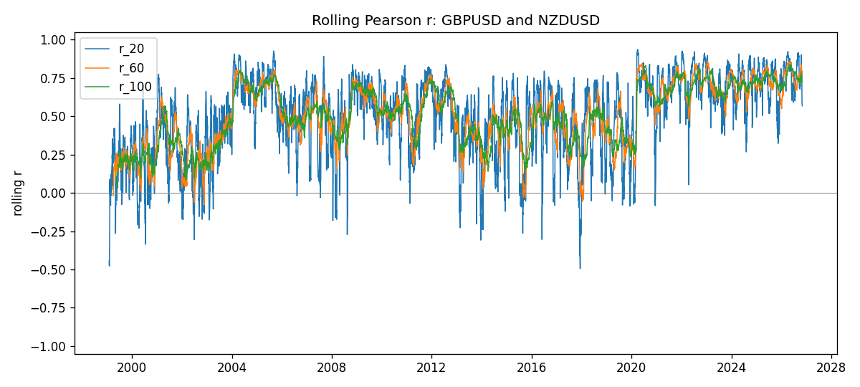
Daily closes

Daily log returns
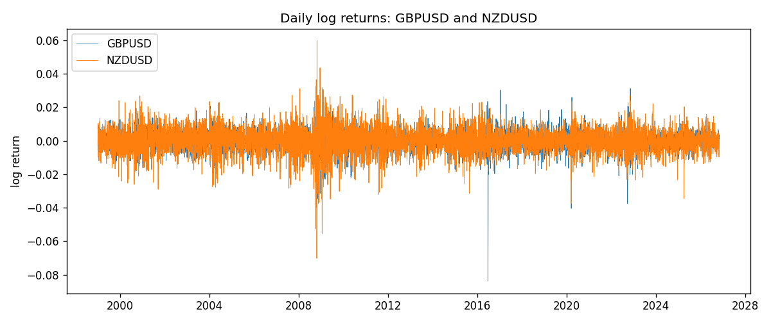

Data report
Every matched row with r_20, r_60, and r_100 is in the sibling CSV and HTML. This Word section holds column summaries and the first and last 15 rows of the rolling table.
Columns: time, GBPUSD_close, NZDUSD_close, GBPUSD_tick_volume, NZDUSD_tick_volume, GBPUSD_log_return, NZDUSD_log_return, r_20, r_60, r_100
Column summaries
column | count | mean | std | min | 25% | 50% | 75% | max
GBPUSD_close | 7203 | 1.5161 | 0.218164 | 1.06879 | 1.32515 | 1.51122 | 1.63196 | 2.1065
NZDUSD_close | 7203 | 0.656248 | 0.108271 | 0.3907 | 0.591395 | 0.6683 | 0.724915 | 0.8822
GBPUSD_tick_volume | 7203 | 94801 | 153533 | 62 | 9991 | 52873 | 91772.5 | 1.27337e+06
NZDUSD_tick_volume | 7203 | 68552.4 | 123031 | 16 | 5500.5 | 33815 | 58467.5 | 1.12768e+06
GBPUSD_log_return | 7203 | -2.372e-05 | 0.00564203 | -0.0838824 | -0.00312422 | 3.221e-05 | 0.0031735 | 0.0311265
NZDUSD_log_return | 7203 | 5.29e-06 | 0.00764545 | -0.0702743 | -0.00426254 | 0.00021291 | 0.00457891 | 0.0596684
r_20 | 7184 | 0.499124 | 0.258716 | -0.49436 | 0.339384 | 0.546144 | 0.702299 | 0.937127
r_60 | 7144 | 0.508131 | 0.202683 | -0.0744237 | 0.365484 | 0.523563 | 0.680276 | 0.860797
r_100 | 7104 | 0.510829 | 0.186486 | 0.025807 | 0.358667 | 0.515921 | 0.682538 | 0.835464
First 15 matched rows
time | GBPUSD_close | NZDUSD_close | GBPUSD_log_return | NZDUSD_log_return | r_20 | r_60 | r_100
1999-01-05 | 1.6547 | 0.5372 | -0.00289663 | -0.00185977
1999-01-06 | 1.6537 | 0.5383 | -0.000604522 | 0.00204556
1999-01-07 | 1.6502 | 0.5417 | -0.00211871 | 0.00629632
1999-01-08 | 1.6405 | 0.5414 | -0.00589542 | -0.000553965
1999-01-11 | 1.6312 | 0.547 | -0.00568513 | 0.0102904
1999-01-12 | 1.6349 | 0.5441 | 0.0022657 | -0.00531575
1999-01-13 | 1.6499 | 0.5387 | 0.00913304 | -0.00997422
1999-01-14 | 1.6531 | 0.5386 | 0.00193763 | -0.000185649
1999-01-15 | 1.6502 | 0.5382 | -0.00175582 | -0.000742942
1999-01-18 | 1.6522 | 0.5372 | 0.00121124 | -0.00185977
1999-01-19 | 1.6553 | 0.5382 | 0.00187453 | 0.00185977
1999-01-20 | 1.6472 | 0.5404 | -0.00490538 | 0.00407937
1999-01-21 | 1.6524 | 0.5426 | 0.0031519 | 0.00406279
1999-01-22 | 1.6565 | 0.5361 | 0.00247817 | -0.0120517
1999-01-25 | 1.6585 | 0.5342 | 0.00120664 | -0.00355041
Last 15 matched rows
time | GBPUSD_close | NZDUSD_close | GBPUSD_log_return | NZDUSD_log_return | r_20 | r_60 | r_100
2026-10-13 | 1.32534 | 0.56127 | 0.00364343 | 0.00473262 | 0.810857 | 0.83126 | 0.720204
2026-10-14 | 1.31884 | 0.55918 | -0.00491647 | -0.00373065 | 0.776354 | 0.829873 | 0.750265
2026-10-15 | 1.32757 | 0.56185 | 0.00659764 | 0.00476349 | 0.858553 | 0.823647 | 0.754131
2026-10-16 | 1.33257 | 0.56509 | 0.00375921 | 0.0057501 | 0.889884 | 0.830612 | 0.767304
2026-10-19 | 1.33024 | 0.56616 | -0.00175003 | 0.00189171 | 0.866093 | 0.821958 | 0.777711
2026-10-20 | 1.3377 | 0.56827 | 0.00559234 | 0.00371993 | 0.901092 | 0.82348 | 0.779286
2026-10-21 | 1.33937 | 0.57003 | 0.00124763 | 0.00309233 | 0.862238 | 0.834654 | 0.780547
2026-10-22 | 1.33967 | 0.56815 | 0.000223961 | -0.00330352 | 0.843093 | 0.809416 | 0.778677
2026-10-23 | 1.33684 | 0.56991 | -0.00211469 | 0.00309299 | 0.787003 | 0.789977 | 0.760934
2026-10-26 | 1.33359 | 0.56826 | -0.00243407 | -0.00289939 | 0.794626 | 0.790055 | 0.762947
2026-10-27 | 1.33044 | 0.56811 | -0.00236484 | -0.000263999 | 0.789903 | 0.785363 | 0.761636
2026-10-28 | 1.33254 | 0.56261 | 0.00157718 | -0.00972839 | 0.641384 | 0.734736 | 0.734803
2026-10-29 | 1.33733 | 0.56296 | 0.00358819 | 0.000621907 | 0.593171 | 0.730406 | 0.729226
2026-10-30 | 1.33913 | 0.56307 | 0.00134506 | 0.000195377 | 0.588854 | 0.72531 | 0.729039
2026-11-02 | 1.3406 | 0.56161 | 0.00109713 | -0.0025963 | 0.568543 | 0.724486 | 0.726667

